HOME CHALLENGE #5: TINY - RED

The goal of this activity is to create a simulation with Cooja with 3 motes. The motes communicate over the radio but only motes ‘#2’ and ‘#3’ can send messages to mote ‘#1’. Mote ‘#1’ will receive the messages and will forward them to a Thingspeak channel (<https://thingspeak.com/channels/1070293>) through a Node-red application.

The first thing done has been to create a new message structure for the Tiny-OS motes. The message is composed by a value(*nx_uint16_t value*) and a topic(*nx_uint8_t topic[10]*). Through this last attribute it has been possible to distinguish the sender of the message.

Regarding the ‘*application code’* the main difference with the previous challenge has been to implement the *‘RandomC’* component. This interface has been used in order to make the simulation more realistic and dynamic. We have also implemented a *“control part”* where we have make possible only to motes #2 and #3 to send messages to mote #1.

With Cooja’s app the simulation has taken part. We have linked the simulation to a Server in order to make a “communication link” with Node-red.

Node-red’s flow is the following :

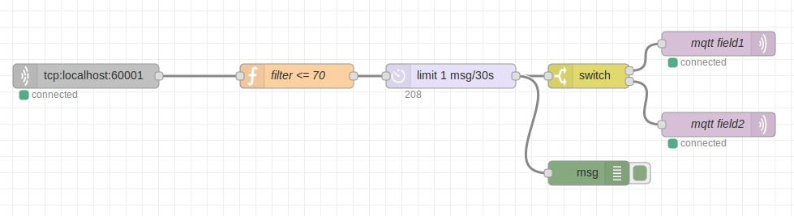

- The “**tcp** block” is used to link Node-red with the Cooja’s simulation.

- The “**filter** block” is used to discard messages where the attribute values was > 70.

- The “**limit** block” allows messages to be sent every 30s.

- The “**switch** block” uses regular regular expressions in order to distinguish messages from mote #2 and mote #3

- The “**mqtt** blocks” are needed for sending messages to the thingspeak channel.

The Thingspeak Channel is composed by two charts, showing respectively the value of the messages from mote #2 and messages from mote #3.

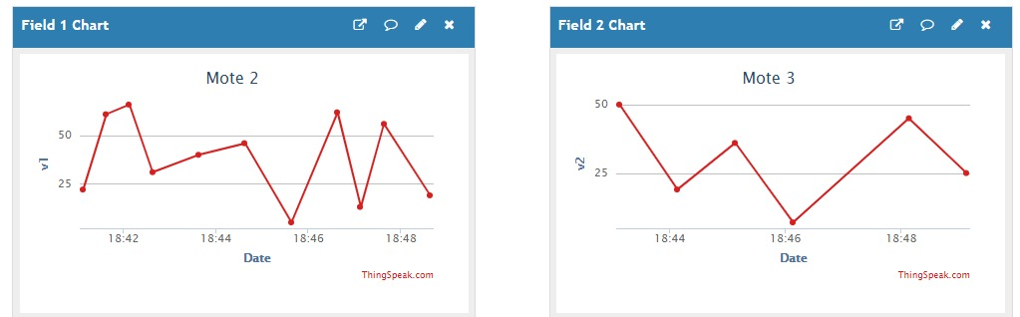

Repository link and contacts

The project repository can be found at the following link: <https://github.com/NonSvizzero/IoT2020>.

Team members:

* Giuseppe Maria Fiorentino (10590418, giuseppemaria.fiorentino@mail.polimi.it)
* Riccardo Novic (10496965, riccardo.novic@mail.polimi.it)
* Raffaele Zenga (10611699, raffaele.zenga@mail.polimi.it)